Solar production of Adinkra ink: summer 2014 final report

How the ink is made
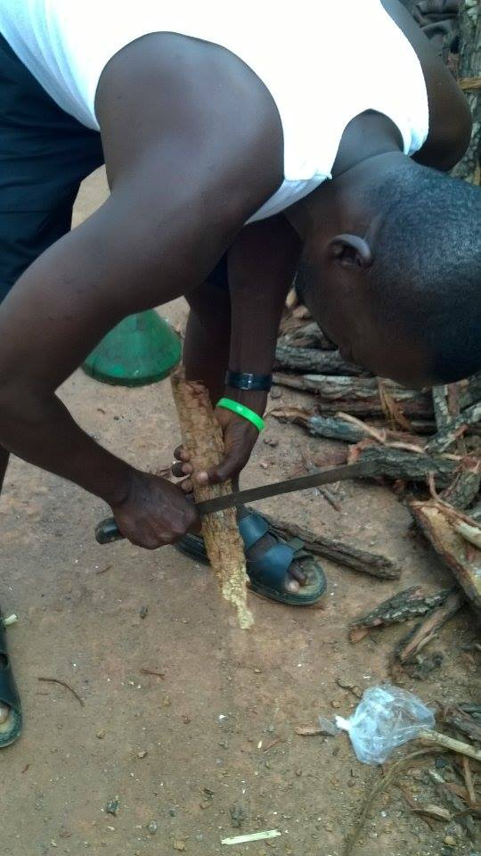
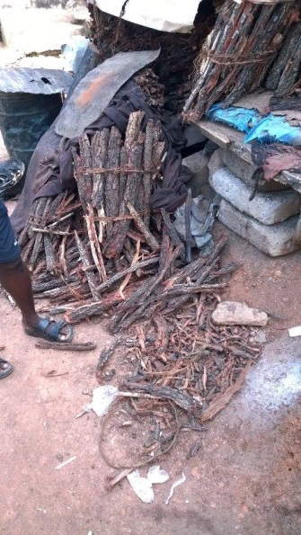
Adinkra ink comes from the bark of the Badie tree. These trees only grow in northern Ghana, and must be purchased by the ink makers in bundles. The amount of ink that can be derived from the bark is dependent on the age of the tree. Bundles contain bark from different tree ages which means the same amount of ink can be made from each bundle.
The bark is scraped to remove dust and dirt before soaking in water. Soaking lasts 2 days in the rainy season and 4 days in the dry season.
Once soaking is completed, the bark is pounded using a wooden MORTAR AND PESTLE until it is the correct fibrous pulpy texture. The dye make Gabriel said machines exist which can do this but they grind the bark too thoroughly so that is unusable and the cost of electricity or gas to run is too high. Gabriel said pounding by hand produces a better result because of the human element. He described how canned banku is not as good as homemade banku, and that canned banku can never satisfy you like homemade banku can. That being said, Gabriel did say however he would “like machine more than 100% if it gave the proper result.
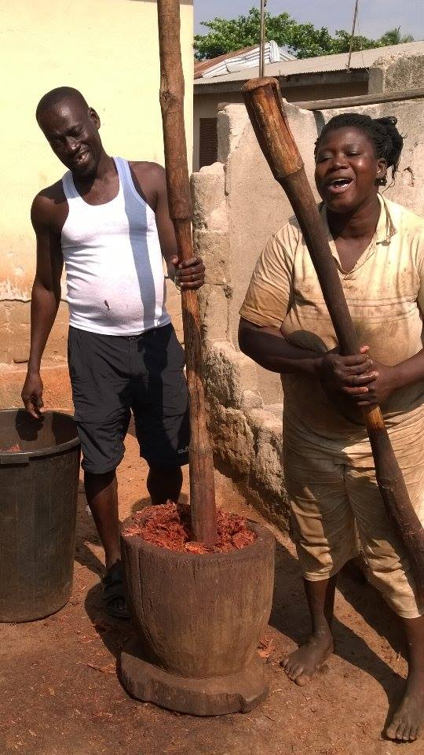
The pulp is boiled while covered for 5 hours. 80 gallons are processed at a time. After this step the bark water is strained and the pulp can be used to grow mushrooms. The pulp can be used to grow mushrooms only after it has been boiled for 5 hours, and not before. It is water every day for a couple of days and then mushrooms will begin to grow. The liquid can be used as a medicine to treat things like an upset stomach and diarrhea.
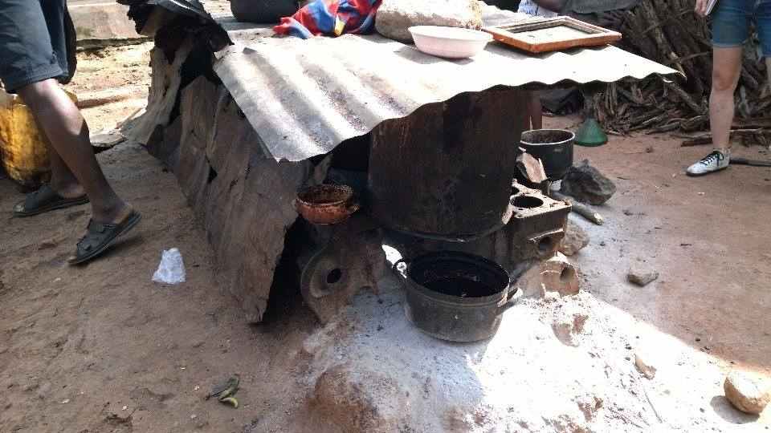
The second boiling lasts 5 hours and is done uncovered, to reduce the ink until it is the right consistency. The ink is not stirred during the boiling but must be closely watched. A difference of 5 minutes will turn the ink into an unusable granulated mixture. The final volume of the ink is 10 gallons
Current Design
The current system is a parabolic solar concentrator with an evacuated tube. The system is pictured below.
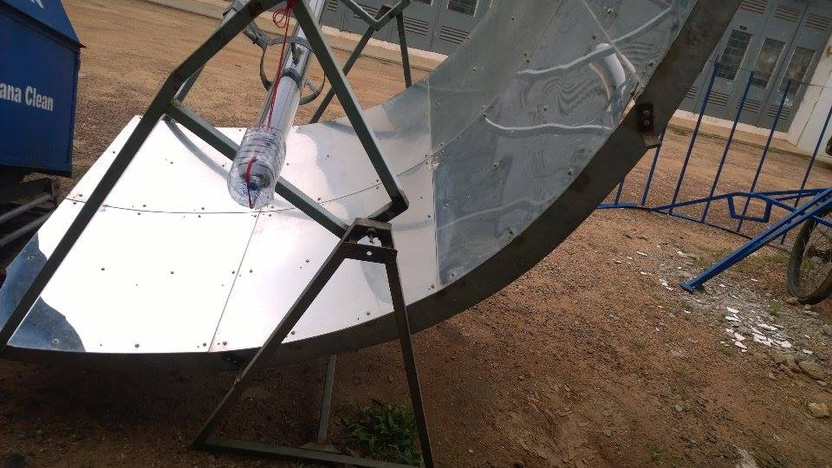
Reflector
The reflector is a mirrored parabolic surface. Bent aluminum creates the parabolic surface, and reflektech mirror film is applied before bending.
To apply by hand, the aluminum sheet must be cleaned thoroughly so that no dust or dirt particles are on the surface. This needs to be done in an area free of dust and other particles.
The aluminum surface is then sprayed with a mixture of water and a few drops of soap. The soap reduces helps to break the water’s surface tension.
Inch by inch at a 45 degree angle, push out the water and bubbles from under the film. This secures the film in place. It is important to be firm even if bubbles do not appear because if any soapy water remains under the surface, while the film settles and cures bubbles will form.
This method was used in Ghana and compared to laminating using a metal bender and laminating by hand without water.
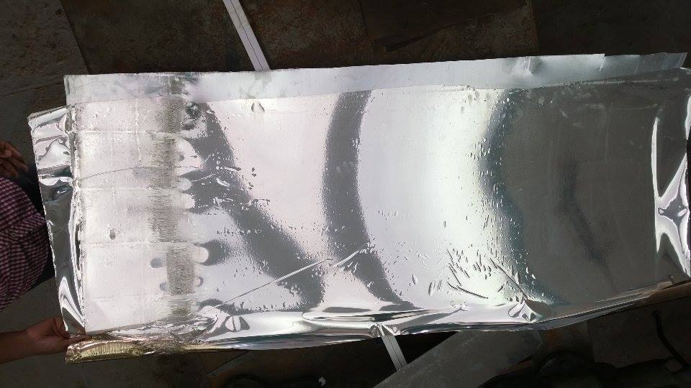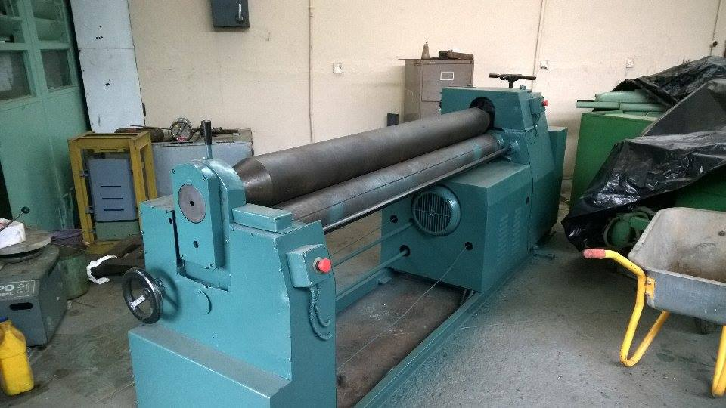
Machine used to laminate above aluminum
Foil after being put through rollers. The rollers seemed to be misaligned because one side of the foil was pressed too hard and warped and torn and the other was not.
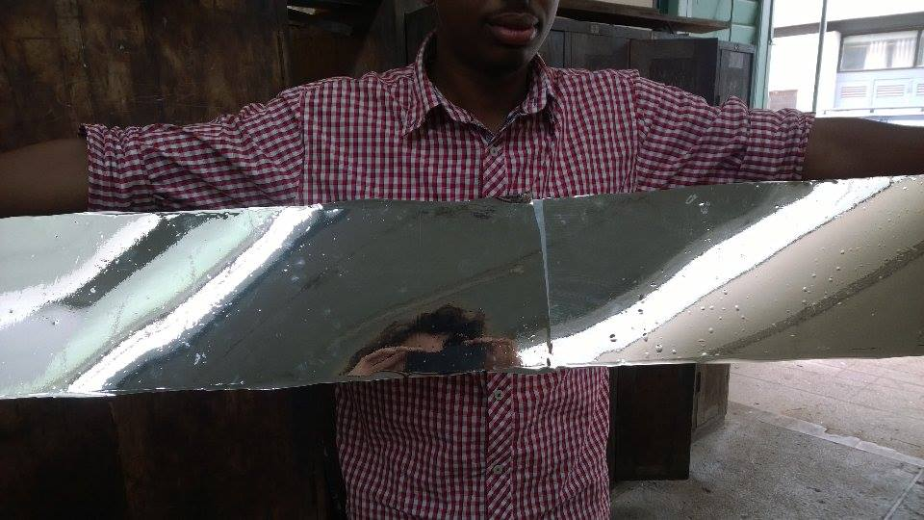
Left side was done by hand using water method, right side was done by hand without w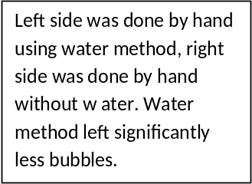ater. Water method left significantly less bubbles.

Heliostat
Feedback
This tracker uses two photoresistors to direct the motion if a motor so that it is aligned properly. There are two circuit wired so that when current flows through one circuit the motor will turn left, and when the current flows through the other circuit, the motor will turn right. The flow of current in these circuits is controlled by using the photoresistors as light-activated on-off switches.
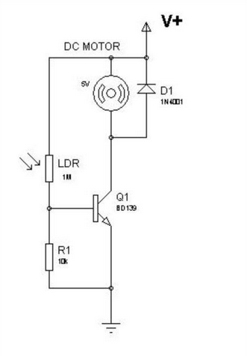
Circuit diagram of dc motor controlled by darkness activated switch. Issue was supplying the correct voltage and identifying the right resistor to use
Timer
The timer approach works by moving the reflector a set number of degrees at specific time intervals. These timing intervals depend on the gearing system used. Using a 555 timer chip was the top choice over arduino for this type of tracker because of cheaper cost.
Manual
The manual heliostat is a back up system in case an electrical system fails or is found to be undesirable. It would allow the dye maker to position the reflector properly by aligning the reflector with the sun (which can be done by using shadows) and then setting the reflector in that position with a pin and hole system
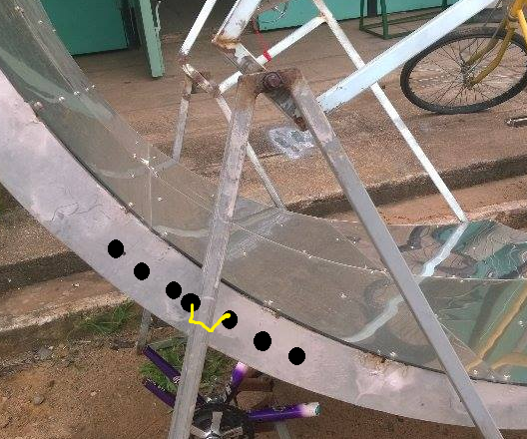
Pins and holes used to lock reflector into place
Gear train
Gear train is dependent on the type of heliostat used. For the timer heliostat the number of rotations the motor is told to do by the circuit must also be the correct amount so when connected to the gear train it moves the reflector the correct amount of degrees. The gear train made in summer 2014 would suit this.
For the feedback system, the circuit needs to be exposed to sunlight and not in a place that the concentrator could cast a shadow on it.
The manual system does not require a gear train.
Testing
Testing needs to be done to determine the feasibility of this design. There are three initial tests the 2014 summer team came up with in order to move forward on this project.
Test 1
Measuring temperature and light intensity every 5 minutes, see how long it takes water in the evacuated tube to boil without any flow. Measure the volume of water before and after to note if any evaporation occurred. This will show how long the ink needs to be in the tube to boil which will inform the allowable flow speed.
Test 2
Repeat test 1 but using the copper bulb heat exchanger that comes with the bulbs. The volume of water to be heated is the same volume that fits inside the tube in test 1, so that the two results can be compared. Measure the volume of water before and after to note if any evaporation occurred. This is to determine the most efficient heat transfer solution.

Alternate design options
The current design does not allow for the necessary evaporation but could be used for the initial boiling. After testing the amount of evaporation that is required will be determined. A couple of options have been discussed to allow evaporation to occur in conjunction with the current design or replacing it all together
An option that could be added to the current design is a thin-film evaporator. This is a vertical tube which liquid slowly flows down in a film over a heated surface. A concern with this design is cleaning the ink out after running it through because it is viscous.
A simpler option would be to have several evacuated tubes with smaller parabolas and the copper bulbs sitting in the trough that the ink was in. This would allow for evaporation to happen because greater surface area exposed to the air.
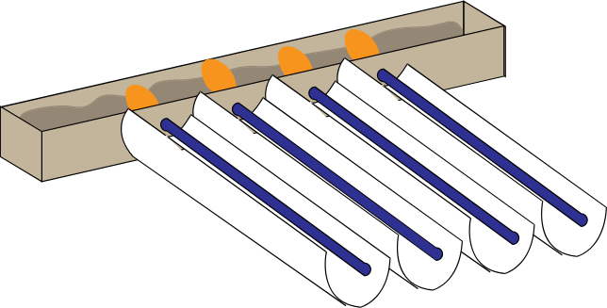
Another design option would be to use the evacuated tubes to generate steam to heat a metal plate and boil droplets of the ink. More information on film drop boiling can be found here http://ntrs.nasa.gov/archive/nasa/casi.ntrs.nasa.gov/19660009079.pdf, and steam generation can be found here http://georgesworkshop.blogspot.com/2012/08/gen20-first-steam-test.html

FRAME SYSTEM

- Reflective surface
Our main aim of modifying the reflective surface is to maintain the parabola, the length to breadth ratio and the projected surface area so as to maintain the focal length of the parabola.

  - How the new design was made
We traced the curve of the parabola from the existing design unto a cardboard in order to get the same curve of the parabola

    - Calculation of the projected surface area

Projected surface area

In the initial design the length of the projected surface area was 4ft and the breadth was 41/6ft.
$$area=4x \frac{41}{6}$$
$$=27.33 ft²$$
In order to maintain the same projected surface area for the new design, we need to fix one of the other measurements. We decided to have the length fixed since it’s going to be based on the length of the glass tubes which is 6ft each.
$$breadth= \frac{27.333}{6}$$
$$=4.56ft$$
We rounded it down to 4ft so that the projected area would still lie in the range of the initial area.

    - Designing
From the calculated value, we measured the breadth from the traced curve and cut out two of it from a 2mm galvanized metal sheet. We filed the edges to obtain a smooth surface.
The two curved plates of arc length 4ft and a height of 3inches were cut out of a steel plate. These plates are place at a distance of six feet apart from each other. Seven 1x1 square metal tubes of length six feet each are placed at a distance of 8inch on the upper edge of the inner parabola of the metal plates.
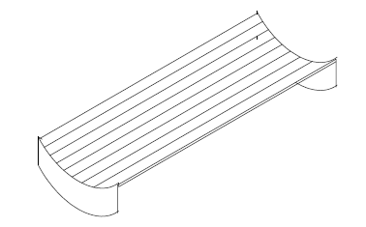

    - Aluminium and reflective material

- Support for the parabola

Another part of the frame is the part that lies on top of the parabola. The measurement from the parabola to the upper part where the hangers lie is 691mm. the diagram below shows a vivid illustration
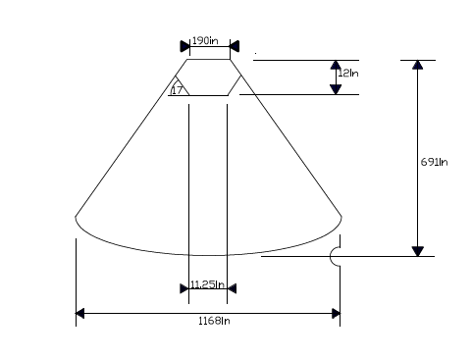

- Stand/legs
The design of the previous stand was maintained.

